## horizontal line



Capstone Project Proposal (Week 3 Draft)

Robotic Air Hockey System  
02.09.2018

David Eelman - 6365316  
Stanislav Rashevskyi - 7028178  
Thomas Abdallah - 7141518

Conestoga College

Electronic Systems Engineering  
Capstone Project I - EECE74125

Semester 7, Class of 2018

**Introduction** **2**

**Literature Review** **2**

**Project Description** **2**

**Project Feasibility** **2**

**Risk Analysis** **3**

**References** **3**

# Introduction (David)

o Purpose: identify the purpose and audience of the document.  
o The Project: name and briefly describe the proposed project.  
o Background  
‒ Identify what problem the project will solve.  
‒ Specify why this problem needs to be solved.

The Capstone Project Proposal will make a case for the Robotic Air Hockey System and will provide a high-level description of how the project will work. The proposal document is intended for review by faculty members of the Electronic Systems Engineering (ESE) program at Conestoga College. The Robotic Air Hockey System will be capable of playing air hockey against a human player. This project will attempt to address the problem of a lack of public knowledge about ESE program at Conestoga College. There is limited marketing material available that showcases the technical knowledge and capabilities taught in the ESE program that can be understood by both technical and non-technical audiences. This problem needs to be solved in order to increase the exposure of the ESE program both within Conestoga College and in the greater public view. Our project will attempt to address this problem by providing a fun and interactive game that can be used for public demonstrations.

# Literature Review

## Electric Motor Types and Applications

<https://learn.sparkfun.com/tutorials/motors-and-selecting-the-right-one>

<http://www.nmbtc.com/brushless-dc-motors/why-brushless-motors/>

Electric motors may be used in this project to control the movements of the air hockey paddle. There are several different types of electric motors, each with their own characteristics that make them suitable for specific applications. Literature discussing the pros and cons of brushed and brushless DC motors, stepper motors, and linear motors was reviewed and is summarized below [reference number].

**Brushed DC Motors**

Brushed DC motors are very popular and are used in a wide range of applications. These motors are affordable, simple to control, and output high torque at low speed. Brushed DC motors may not be suitable for all applications as the brushes wear out over time, can generate electromagnetic noise, and have limited speed due to brush heating.

**Brushless DC Motors**

Brushless DC motors are becoming more popular as cheap microcontrollers have made it possible to control them in a wide range of applications. These motors are more efficient and reliable than brushed DC motors, and can achieve higher speeds. Brushless DC motors are more difficult to control than Brushed DC motors.

**Stepper Motors**

Stepper motors are commonly used for position control as they do not require an encoder which makes them very simple to use. Stepper motors are highly commoditized and are very reliable as they do not use brushes. Stepper motors are limited in top speed due to small stepping distances and may miss steps under high loads resulting in incorrect position measurements.

**Linear Motors**

Linear motors eliminate the need to have a mechanical device convert rotational motion to linear motion resulting in low friction and therefore higher speeds. Linear motors only have one moving part so they are very reliable and simple to maintain. Linear motors are very expensive as they are usually purpose built for each application and require custom controllers.

**Comparison of motor types (Thomas)**

* + <https://learn.sparkfun.com/tutorials/motors-and-selecting-the-right-one>
  + Brushed DC motor
    - Pros: Cheap, high torque at low speed, simple control
    - Cons: Brushes wear out, limited speed due to brush heating
  + Brushless DC motor
    - Pros: High speed, more efficient
    - Cons: Difficult to control, requires low starting loads
  + Stepper motor
    - Pros: High position accuracy without requiring encoders
    - Cons: Limited top speed, missing steps under high loads, inefficient
  + Linear motor (unrolled brushless motor)
    - Pros: High speed, efficient, no rotary to linear mechanical conversion required
    - Cons: Expensive, difficult to control, not available off the shelf (custom design for each application)

o Survey on existing solutions for this problem (citation of authoritative  
source required. Authoritative source includes well-known  
technical/scientific journals, magazines, industry white papers,  
product descriptions from original vendor).  
o Compare your solution to existing solutions

* **Examples of existing air hockey robots**
  + Thomas
    - 3D printer parts + Linux box for object tracking & control strategy (<https://www.jjrobots.com/air-hockey-robot-a-3d-printer-hack/>)
    - 3D printer parts + Android phone for object tracking & control strategy (<https://www.jjrobots.com/the-open-source-air-hockey-robot/>)

## Object Tracking Methods

An object tracking method will be required in this project to track the position and speed of the air hockey puck. There are many ways to track an objects motion, and in the literature review below is a summary of the pros and cons of common methods: magnets, vision, and ultrasonics.

**Magnets**

Using magnetic sensors for tracking position and orientation of a magnetic object has become a popular area of testing and study in the medical field due to it’s non-invasive nature. This method of object tracking requires an array of sensors directed towards the moving magnetic object. An inexpensive, low-power solution, however, instability and inaccuracies of magnetic readings would likely cause difficulty in velocity calculations for the object in motion. As well, the object would need to be fitted with a magnet, changing its physical properties.

**Vision**

Object tracking using vision systems has improved drastically in the last decades, and open source solutions have simplified the process to level suitable for academic purposes. A vision system is more accurate and consistent, providing sufficient data for determining the position and speed of the object in motion. This solution would be more costly due to the need for a camera and a processing unit capable of pulling the relevant data from the images.

**Ultrasonics**

Another method of object tracking is ultrasonic sensors, which use sound waves reflected off the target to measure distance to the target. While ultrasonic sensors can measures very quickly and are cost effective, it would be difficult to design an array of sensors to cover a large surface with a small target object.

* + - Magnets (<http://ieeexplore.ieee.org/stamp/stamp.jsp?arnumber=7496898>)
    - Vision (<https://pdfs.semanticscholar.org/25a6/c5dff9a7019475daa81cd5a7f1f2dcdb5cf1.pdf>), (<http://www8.cs.umu.se/education/examina/Rapporter/SannaAgrenFinal.pdf>)
    - Ultrasonic (<https://www.allaboutcircuits.com/projects/create-an-object-tracking-system-integrating-servo-control-with-object-dete/>), (<http://engineering.nyu.edu/mechatronics/summit/SUMMIT2007/group6-Will_Bill/Summit2007Project.pdf>)

## HMI Design & Implementation Options

The project will include a Human Machine Interface (HMI) in order to satisfy the requirement of having a user interface that allows the system to be demonstrated to both technical and non-technical audiences, as well as a debug interface for system troubleshooting. A few options for HMI are discussed below with pros and cons listed for each suggestion.

**QT**

A cross-platform application framework that is a popular choice as an HMI. Familiarity by a group member would lead to quick development of features.

**Python**

A command line interface using Python is simple and takes little time to develop. A less comfortable user experience for non-technical users, however as the debug interface for technical users it would be optimal.

**Mobile Application**

Using a mobile application as an HMI provides portability to the system. The portability would be especially useful for demonstrations and showcasing. Limited application development experience by the group may bring this out of scope for the project.

**Website**

A website running locally on the master controller would provide the necessary HMI for the system, both user and debug interface. The groups expertise in website development from Semester 7 would allow for a clean, versatile solution.

## Air hockey strategy

In order to to understand the game the project software will include different aspects of air hockey rules. To make project challenging and entertaining for players with different skills, the system will have to utilize fundamental strategies for offense, defense, tips, trick shots, etc. To fulfill the above plan, the air hockey paddle will have to interfere with a puck in 2D motion. The above points are discussed below with some comments.

**Rules**

First player to reach 7 points wins the game. Point is counted when the puck breaks the horizontal plane inside the opponent’s goal. Once the puck is on a certain player’s side of the center line, he/she has 7 seconds to hit the puck back across the center line. Any fouls or score (e.g. “topping”, puck leaves the table, etc) can be informed via HMI.

**Tips and Strategies**

In offense puck should never need to bank off more than one wall before it goes in your opponent's goal, as it slows down after hitting each wall. Also the system has to watch out for ricochets after its’ own shots, so the paddle needs to be moved in a defense position right after each attack.  
Gaming algorithms will need to vary shots, and keep track of decisions that happened to be successful in the game (e.g. use different walls for bank shots, use trick shots, change interval between each shot).

**Offense**

Shooting zone (shown on Figure 1) is an invisible semicircle behind the centerline on your side of the table that has the highest percentage to score from. A rule of thumb by professional players is to take 90% of the shots form the zone. In order to do that the paddle mechanism will need to be able to stop and drift puck quickly to the shooting zone.

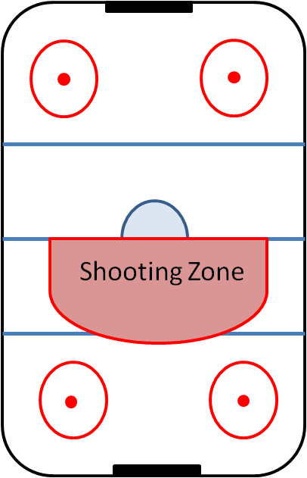

Figure 1 – Air Hockey Shooting Zone

Straight shot only used when your opponent is leaving a gap in their goal open on defense directly across from the position of the puck on your side of the table. Angle shot are two most popular and effective shots, as they are more deceptive and hard to read.

**Defense**

The puck has to be constantly followed. Paddle in the moment of an opponent’s shot needs to be moved to the area around your goal. The triangle style defense is probably the most common method to playing the game.

**Machine Learning**

In air hockey each player adapts to the opponent’s gaming style. Machine learning would also allow our system to readjust and counteract unusual techniques demonstrated by new players, and make each move unique. Nowadays, Artificial Intelligence is widely and successfully used in gaming industry, even in more complicated games than air hockey (e.g. Dota 2, StarCraft, Chess, etc). Though, no past machine learning experience among group members might bring this out of scope for the project.

## Communication Methods in Distributed Embedded Systems

The project will include multiple number of major components (Puck Tracker, Paddle Controller, Master Controller, User Interface) that will need to communicate between each other. There are many protocols for network design available on the market today. Some wired and wireless protocols will be discussed below with pros and cons listed for each suggestion.

**CAN (wired)**

CAN bus is the most used network protocol in vehicles today. It may connect multiple nodes together. The maximum signaling rate is 1Mbps, which might be not fast enough for realtime video transmission. Due to previous ESE project experience CAN should be an easy to implement networking solution.

* **Air hockey strategy**
  + Stan
    - All about air hockey (<http://www.bubbleairhockey.com/air-hockey.html)>
    - Rules <https://www.libertygames.co.uk/blog/air-hockey-the-rules/>
    - Machine learning for playing games
      * Air hockey AI tutorial in Unity <https://www.youtube.com/watch?v=ZlAMVEVHkuI&list=PLB6lc7nQ1n4hLTDIPJiUD6OlBSNvtp7YP>
      * <https://blogs.unity3d.com/2017/12/11/using-machine-learning-agents-in-a-real-game-a-beginners-guide/>
      * <https://blog.openai.com/dota-2/>
      * <https://www.techemergence.com/machine-learning-in-gaming-building-ais-to-conquer-virtual-worlds/>
* **Mechanisms for high speed linear position/velocity control (Thomas)**
  + Types of linear actuators: <https://en.wikipedia.org/wiki/Linear_actuator>
    - Electromechanical
    - Hydraulic
    - Pneumatic
    - Piezoelectric
  + Belt driven carriage
    - <https://www.jjrobots.com/the-open-source-air-hockey-robot/>
  + Ball screw mechanism
    - Multiple designs – load mounted on sliding carriage or load mounted directly to end of screw rod
    - <http://www.orientalmotor.com/applications/linear-positioning.html>
  + Pneumatic linear actuator
    - <http://blog.parker.com/know-your-pneumatics-hints-tips-for-specifying-linear-actuators>
  + Hydraulic linear actuator
    - High force, difficult to control
  + Piezoelectreic actuators
    - Small range of motion, high precision, low accuracy (due to hysterises)
* **HMI design & implementation options**
  + David
    - Qt, Python, mobile App, website, etc
    - Building a Good HMI (<https://www.automation.com/pdf_articles/opto_22/2061_High_Performance_HMI_white_paper.pdf>)
    - Qt (<http://www.embeddeduse.com/2014/04/19/why-use-qt-for-embedded-systems/>)
    - PyQt and Rpi (<https://www.baldengineer.com/raspberry-pi-gui-tutorial.html>)
    - Website (<https://www.embeddedarm.com/blog/creating-a-human-machine-interface-hmi-web-application/>)
    - Smartphone (<https://www.controleng.com/single-article/an-iphone-as-your-next-hmi/ee2900d7d9c4382803be2b547c767c87.html)>
* **Communication methods in distributed embedded systems (CAN, ethernet, bluetooth, wifi etc)**
  + Stan
    - <http://www.artist-embedded.org/docs/Events/2010/MoroccoSchool/slides/almeida-rtn-rabat-2010-2spp.pdf>
    - CAN vs TTA <https://pdfs.semanticscholar.org/d934/d7edb37e61a8f2f0b4d60ed117721d2705e3.pdf>
    - Network Protocol Design for Distributed and Networked Embedded Systems <http://engr.uconn.edu/~song/classes/nes/slides/nes-intro.pdf>
    - Communication protocols <https://www.slideshare.net/EmertxeSlides/communication-protocols-31945098>

# Project Description (David)

## Overview

The proposed project includes the design, integration, and validation of a robotic system capable of playing air hockey against a human player. This project will serve as demonstration of the capabilities of ESE students for the general public. This project will supplement existing marketing videos [2] with a fun, interactive game that can be used at open houses and recruiting events. This project will have a positive impact on the ESE program by increasing the programs exposure both within the academic community, and by providing outward visibility for potential students, employers, and industry partners. This project may also serve as a platform to allow disabled people to play air hockey, or for professional players to train against.

The proposed system will include mechanical, electrical, and software components. The development of this system will draw on the technical knowledge and skills learned in the Electronic Systems Engineering program while challenging the group members to learn new skills and techniques to successfully implement the project.

The mechanical portion of the system will utilize off-the-shelf components and open-source designs as much as possible. The electrical portion of the project will use off-the-shelf components (ex: motors, microcontrollers) where possible and may reference open-source designs. The software portion of the project may leverage open-source libraries (eg: OpenCV) and may reference open-source designs [1].

## Proposed Design & High Level Specifications

This project will improve upon an existing open-source design that was implemented using hardware and software from a 3D printer [1]. The proposed system will utilize the open-source computer vision library OpenCV [3] to track the location of the puck on the playing surface and calculate its speed and trajectory. A mechanical system capable of moving an air hockey paddle in two-dimensions shall be implemented based on the design presented in the aforementioned open-source project [1]. The electrical system to control the movement of the air hockey paddle may be implemented using off-the-shelf hardware. The software to control the system shall be our own. A user interface shall be implemented to allow the system to be demonstrated to both technical and non-technical audiences. Thorough documentation and a debugging interface shall be provided to enable ESE staff members to maintain and demonstrate the project after the group members have graduated.

## System Overview Block Diagram

The block diagram shown in Figure 1 shows the major components in the proposed system design.

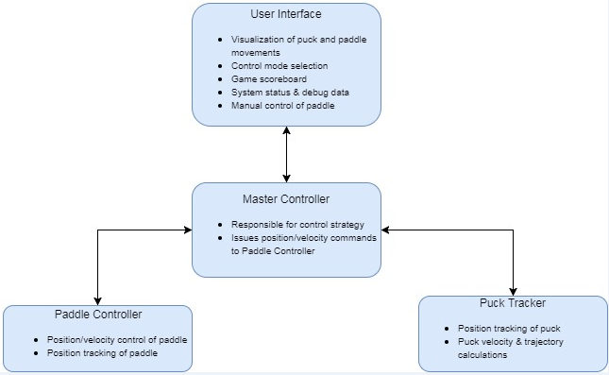

Figure 1 - System Overview Block Diagram

## 

## High Level Schedule

Figure 2 shows our intended development schedule and alignment with the ESE capstone project roadmap.

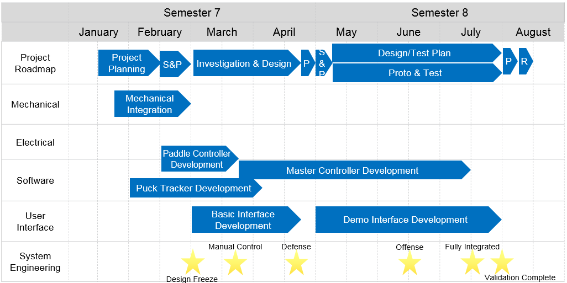

Figure 2 - High Level Schedule

## Milestones

### System Design Freeze

* Functional requirements documented for complete system
* Technical requirements documented for each module/component
* API documented for all digital communication interfaces
* Proof of concept demonstrated for key technologies
  + Vision based puck tracking
  + Mechanism for controlling paddle position

### Paddle Controller Feature Complete

* Electromechanical system capable of controlling paddle position & velocity in 2-dimensions
* Position tracking & reporting of the air hockey paddle
* Communication with Master Controller Implemented

### Manual Control of Paddle

* Manual control of paddle using proposed architecture (commands sent to Paddle Controller via Master Controller)
* User input from keyboard or gamepad

### Puck Tracker Feature Complete

* Puck Tracker capable of tracking puck position in real time
* Puck Tracker capable of calculating puck velocity and trajectory in real time
* Communication with Master Controller implemented

### System Integration Milestone I

* Functional robotic air hockey system implemented
* Basic “defensive” control strategy implemented
  + Robot only tries to stop human player from scoring
* Basic user interface implemented
  + Manual control of paddle position
  + Display of system debug data (eg: puck position, module states)

### User Interface Mockup Complete

* Proof of concept for user interface implementation
* Demonstration of technologies to be used for visualization of puck and paddle position and trajectory
* No communication with Master Controller

### System Integration Milestone II

* “Offensive” control strategy implemented
  + Robot will strategically add energy to the puck in order to try and score goals against the human player
* User interface mostly implemented
  + Ability to switch between defensive/offensive control modes
  + Visualization of puck and paddle position and trajectory

### System Integration Milestone III

* Fully integrated, feature complete system
* Robust hardware, software, user interface, diagnostics, etc

### System Validation Complete

* Requirements driven test plans written and executed

### Simulator Feature Complete (Aspirational)

* Simulated playing environment to enable testing of alternative control strategies or training a neural network
* Dynamics of Paddle Controller modelled based on real-world data
* Visualization of simulated playing environment

### Machine Learning Control Strategy Demonstration (Aspirational)

* Demonstration of a neural network trained to control paddle position/velocity in order to maximize points differential against the opponent in a simulated environment

**Identify professional responsibility attributes (what does that mean?)**

**How much do they want here? We had a lot of detail in the outline.**

o Describe what the proposed system will be and/or do.  
o Identify what will be achievable after the project is complete that isn’t  
achievable now.  
o Identify project context as adding societal, industrial (business or  
entrepreneur) and/or economic value.  
o Identify professional responsibility attribute(s) such as safety, ethics,  
societal impact and environmental concern.

# Project Feasibility

## Expertise

This project will draw upon much of the skills and knowledge learned in the ESE program including embedded system design, software engineering, control theory, operating systems, and electromechanical systems. This project will require acquiring knowledge in the areas of autonomous control strategies, object tracking methods, and mechanical design. The ESE faculty and online references will provide technical expertise to help complete this project.

o Expertise  
‒ identify the knowledge and skills that are required for successful  
completion of the project  
‒ identify any knowledge must be acquired to complete this project  
‒ identify sources of expertise that are available to help complete this  
project  
‒ identify possible external advisors for this project

## Resources

Successful completion of this project will require regular access to the ESE lab space. This project may also rely on other Conestoga College resources such as the 3D printer and machine shop. This project may utilize open source software libraries. This project may utilize mechanical components based on open source designs. The total budget for this project shall be less than $500 CAD. The Air Hockey table will be donated by one of the group members’ families. Where possible the group will use hardware that has already been purchased (ex: Semester 4 robot controllers). This project may be sponsored by the ESE program as it will have a positive impact on the program by increasing the programs exposure both within the academic community, and by providing outward visibility for potential students, employers, and industry partners.

o Resources  
‒ identify the tools and resources that are required for successful  
completion of the project  
‒ Specify the estimated cost of the project.  
‒ Identify possible sponsors of this project.

# Risk Analysis

Based on the risks we have evaluated in the table below, we have determined that the overall risk for this project is low.

|  |  |  |  |
| --- | --- | --- | --- |
| Risk (Priority Highest to Lowest) | Category | Impact on Project Objectives | Potential Risk Reduction |
| 1. Mechanical design/integration problems | Technical | Unable to control robot motion | -Start mechanical prototyping early  -Leverage group members Mechanical Engineering experience |
| 2. Real-time object tracking problems | Technical | Unable to automate robot motion | -Start object tracking prototyping early  -Leverage proven open-source object tracking solutions |
| 3. Security of project in shared classroom | External | Lack of lab workspace availability.  Potential damage to project hardware. | -Utilize dedicated ESE lab space  -Advocate for continued support of ESE dedicated lab space |
| 4. Catastrophic loss of data | Organizational, external, technical | Schedule delays. | -Utilize source control for all project materials  -Manually back up all data once per week |
| 5. Managing scope creep | Organizational, project management | Schedule delays.  Lack of focus on core features. | -Strictly define scope of project during planning phase  -Additional features shall only be implemented after 100% completion of core project features |
| 6. System sizing incorrect | Technical, performance | Lower than desired system performance. | -Use system level performance requirements to drive component design  -Define system level performance requirements based on real-world data |
| 7. Inexperience with HMI design & implementation | Technical | Less relatable demonstration.  Worse user experience.  Difficult to debug. | -Define user interface features early (see: Managing scope creep)  -Start HMI prototyping early  -Utilize popular GUI implementation solutions |

The risk analysis is a document that describes which risks might affect the  
project. It is part of the Proposal. It includes:  
‒ technical, quality and performance risks

‒ project management risks  
‒ organizational risks  
‒ external risks  
The risk analysis report must include:  
‒ an evaluation of the impact of each risk on the major project  
objectives  
‒ the overall risk for the project  
‒ a list of prioritized risks

# References

Template with examples:  
[1] J. Yick, et al., "Wireless sensor network survey," Computer  
Networks, vol. 52, pp. 2292-2330, 2008.  
[2] Y. E. Krasteva, et al., "Remote HW-SW reconfigurable Wireless  
Sensor nodes," in Industrial Electronics, 2008. IECON 2008. 34th  
Annual Conference of IEEE, 2008, pp. 24832488.  
[3] J. Jones. (1991, May 10). Networks (2nd ed.) [Online access on  
June 14, 2016]. URL: http://www.atm.com,  
For more examples see: http://www.ieee.org/documents/ieeecitationref.pdf  
Note: You may use the built in Bibliography functionality in word. We  
recommend the IEEE 2006 Style.